

**Module Code & Module Title**

**CC4057NI Introduction to Information Systems**

**Assessment Weightage & Type**

**30% Individual Coursework**

**Year and Semester**

**2019-20 Autumn**

**Student Name:**

**Group:**

**London Met ID:**

**College ID:**

**Assignment Due Date:**

**Assignment Submission Date:**

*I confirm that I understand my coursework needs to be submitted online via Google Classroom under the relevant module page before the deadline in order for my assignment to be accepted and marked. I am fully aware that late submissions will be treated as non-submission and a marks of zero will be awarded.*

Table of Contents

1. Introduction 1

Goals 1

Objectives 1

2. Discussion And Analysis 3

Uses of text editor 3

Tools used for wireframes (Balsamiq Wireframes) 3

Home Page: 3

Screenshot of wireframe of home page 3

Screenshot of homepage in browser 3

CV Page 3

Screenshot of wireframe of cv page 4

Screenshot of cv page in browser 4

Blog Page 4

Screenshot of wireframe of blog page 4

Screenshot of blog page in browser 4

Research Page 4

Screenshot of wireframe of research page 4

Screenshot of research page in browser 4

Contact Page 4

Screenshot of wireframe of contact page 4

Screenshot of contact page in browser 4

3 TESTING 5

Nav Hover Effect 5

TEST 1 5

Output 6

Internal Link 7

OUTPUT 8

External Link 9

OUTPUT 11

Form Validation (JS) 12

OUTPUT 13

Dynamic Date and Time (JS) 14

OUTPUT 15

IMAGE Slider (JS) 17

**List of Figures**

**List of Tables**

# Introduction

This coursework gives me the ideas and details about the web designing languages such as HTML (Hypertext Markup Languages), CSS (Cascading Style Sheet) and JavaScript. The main theme of doing or completing this project is to make our own portfolio websites. HTML, CSS and JavaScript are the three languages that are used to design the website. The text-editor or IDE (Integrated Development Environment) is used in this website is Visual Studio Code by Microsoft.

HTML is utilized for creating web pages and web applications. HTML when used with CSS and JavaScript form a stunning web pages and some phases for dynamic content also. Whereas CSS is used for designing website using different attributes. CSS makes website very attractive. JavaScript is a first-class compiled programming language that is lightweight, interpreted, or just-in-time compiled. While it is best known as a scripting language for web pages, it is also used in a variety of non-browser environments, including Node.js, Apache, CouchDB, and Adobe Acrobat.

This website contains of five webpages that are home, blog, contact, research and CV. A home page section was the website welcome page or an index page. This page has proper navigation, logo and have background picture. This page consists of some text and button which navigates to CV page. Also, index page has some details of other pages as well as footer section including social icons containing external links.

Second page was my cv page, this page contained different section and divisions where many contents were placed. This page contains about me, skills and my details. As well as footer section same as index page. This page also had a detail section which introduced about me and my qualifications.

Third page was my blog page, this page consists of topic, content of blog and author details. The topic was about technology affects in student life.

Fourth page was my research page, this page has the references of all content that was used in my website such as navigation bar, footer container and many more.

Fifth page was my contact page where anyone can contact me through their name email and their message including form validation using java script.

## Goals

* To make a designed and workable site by own idea.
* To learn proper way of writing codes.
* Proper justification for the usage of different CSS.

## Objectives

* Learn how to make a proper site.
* Learn to use different elements for making a site.
* Learn to use scripting language in a site.
* Learn to nest a proper coding.

When making websites HTML is used by writing tags and elements, CSS is used by writing elements for designing content which were made by HTML elements and tags. Internal, inline and external CSS were used for designing content of websites. Java Script were also used as internal and external for different dynamic operations in websites.

Overall, this coursework guides me to make static web page of our own by using HTML, CSS and JavaScript. This helps in gaining knowledge on different HTML tags, CSS attributes and JavaScript function and libraries. I also gain knowledge on IDE i.e., visual studio code which helps to develop the website in very short time.

# Discussion And Analysis

To make this website I had used text editor or IDE is Visual Studio Code by Microsoft. It is lightweight but powerful source code editor which runs on your desktop and is available for Windows, macOS and Linux. It comes with built-in support for JavaScript, TypeScript and Node.js and has a rich ecosystem of extensions for other languages (such as C++, C#, Java, Python, PHP, Go) and runtimes (such as .NET and Unity).

## Uses of text editor

Text editor is very useful and it makes very easy to develop an website in short time. This makes indentation and makes good formatting while developing websites and writing code. Text editor makes works very easy. It helps in automatic indenting, parenthesis matching, syntax highlighting, line numbering. When we write code, a good choice of text editor can make us much more accurate and efficient.

## Tools used for wireframes (Balsamiq Wireframes)

First of all, wireframes means making blueprint or the pre design of website that we are making in future. For doing this coursework or making this website I had used Balsamiq Wireframes. This tool helps me to reach out easily through wireframes and predesigned website. The content that are needed to make website are properly managed with the help of wireframe. Balsamiq Wireframes is a rapid low-fidelity UI wireframing tool that reproduces the experience of sketching on a notepad or whiteboard, but using a computer. It really forces us to focus on structure and content, avoiding lengthy discussions about colours and details that should come later in the process.

In this website there are five pages that are index or home, cv, blog, research and contact. Contents that are used to designed or content that are in these pages are described below respectively with wireframes and screenshot of each page.

## Home Page:

This page is the landing page or index page of the website. This page has proper navigation, logo and have background picture. This page consists of some text and button which navigates to CV page. Also, index page has some details of other pages as well as footer section including social icons containing external links.

### Screenshot of wireframe of home page

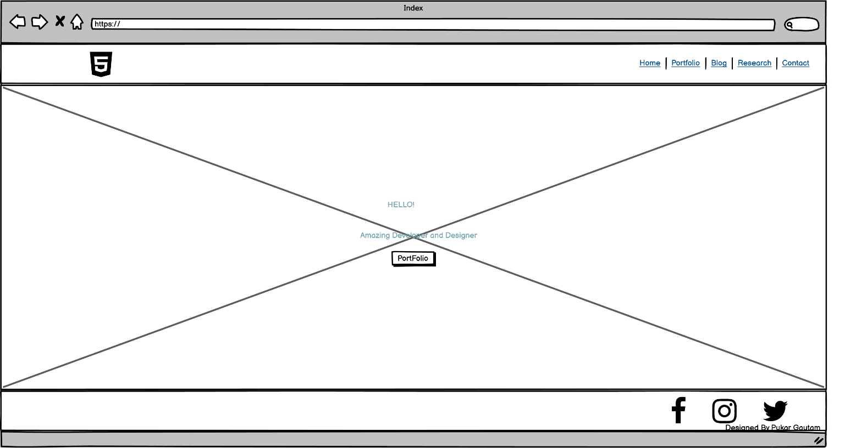

### Screenshot of homepage in browser

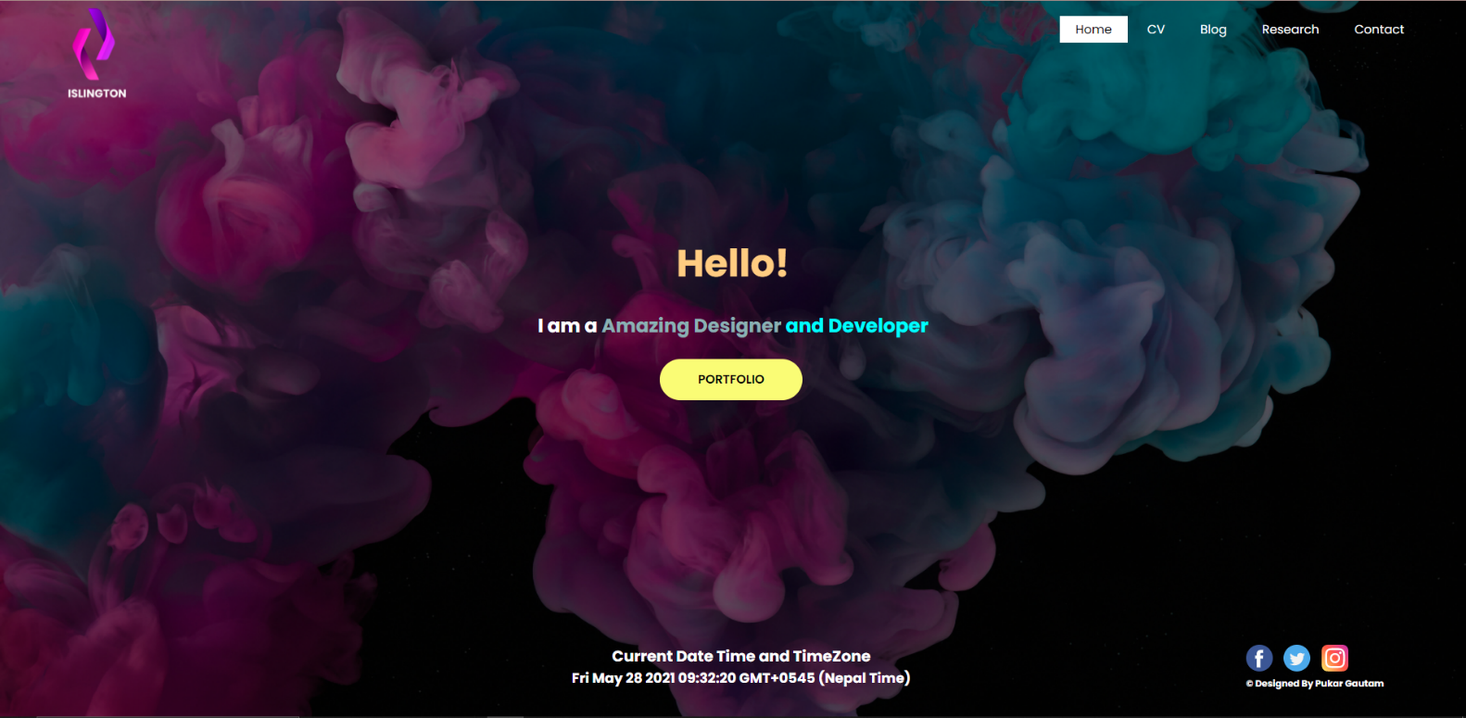

## CV Page

Second page was my cv page, this page contained different section and divisions where many contents were placed. This page contains about me, skills and my details. As well as footer section same as index page. This page also had a detail section which introduced about me and my qualifications.

### Screenshot of wireframe of cv page

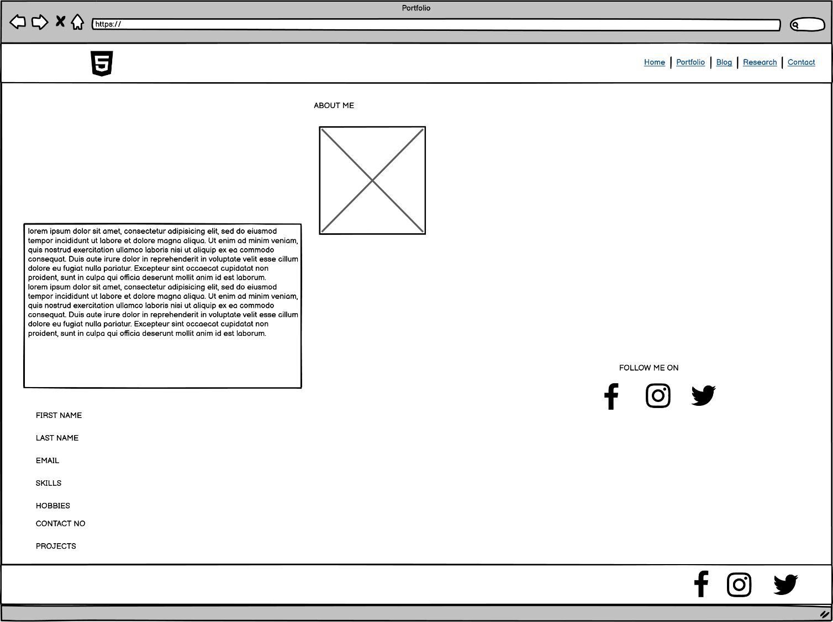

### Screenshot of cv page in browser

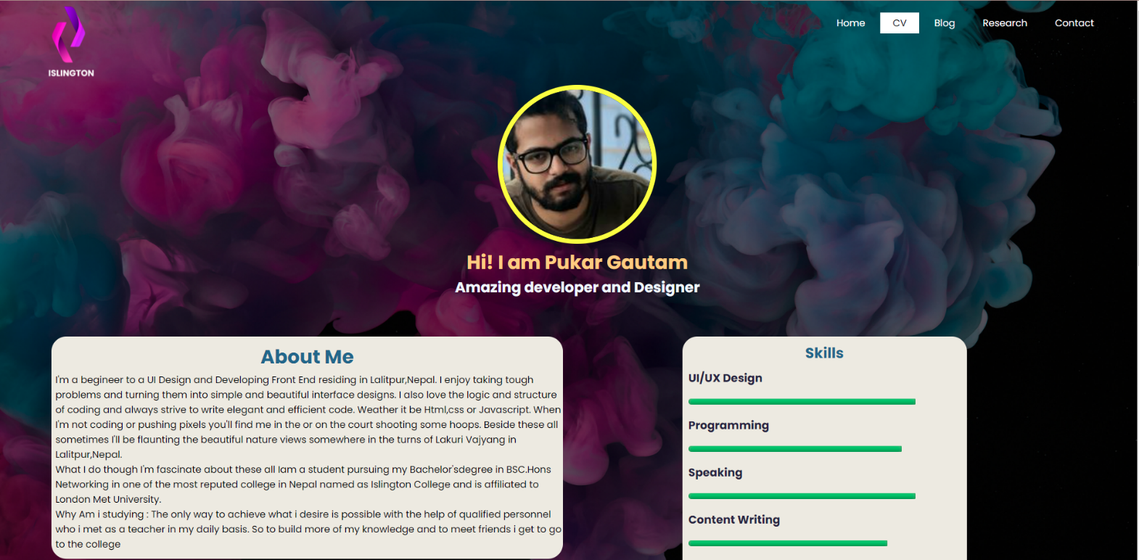

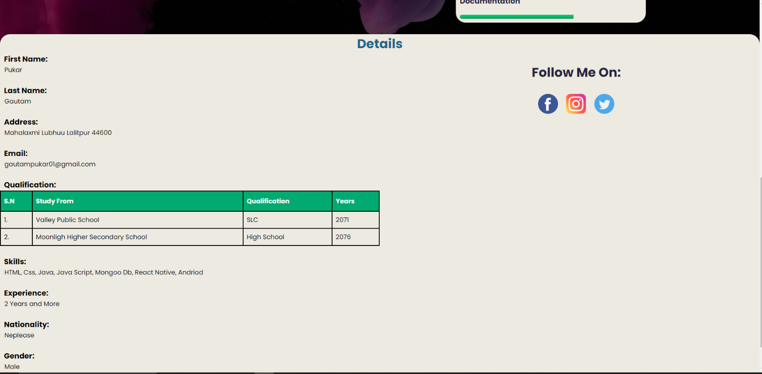

## Blog Page

Third page was my blog page, this page consists of topic, content of blog and author details. The topic was about technology affects in student life.

### Screenshot of wireframe of blog page

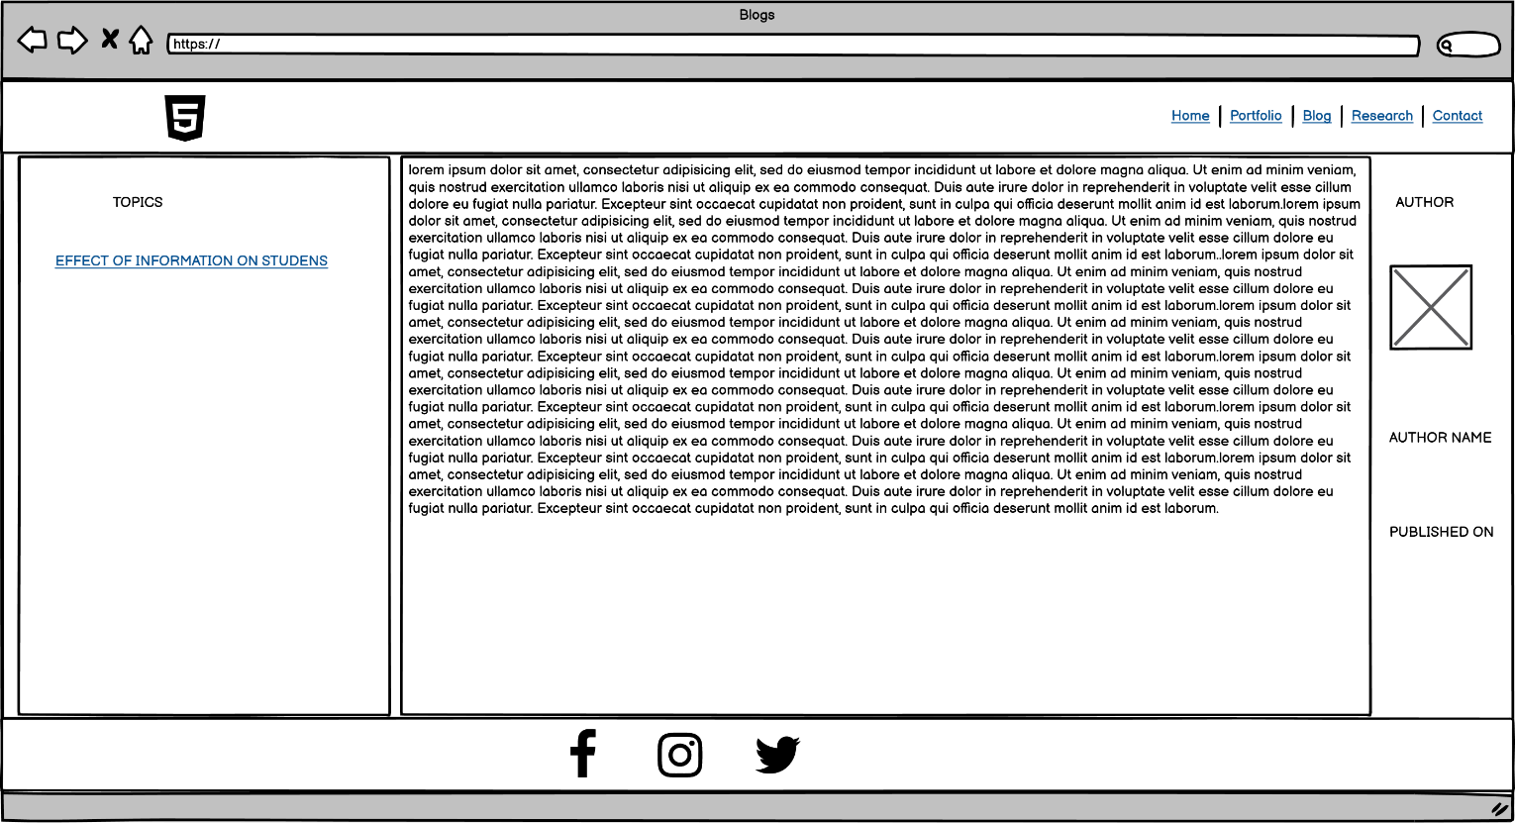

### Screenshot of blog page in browser

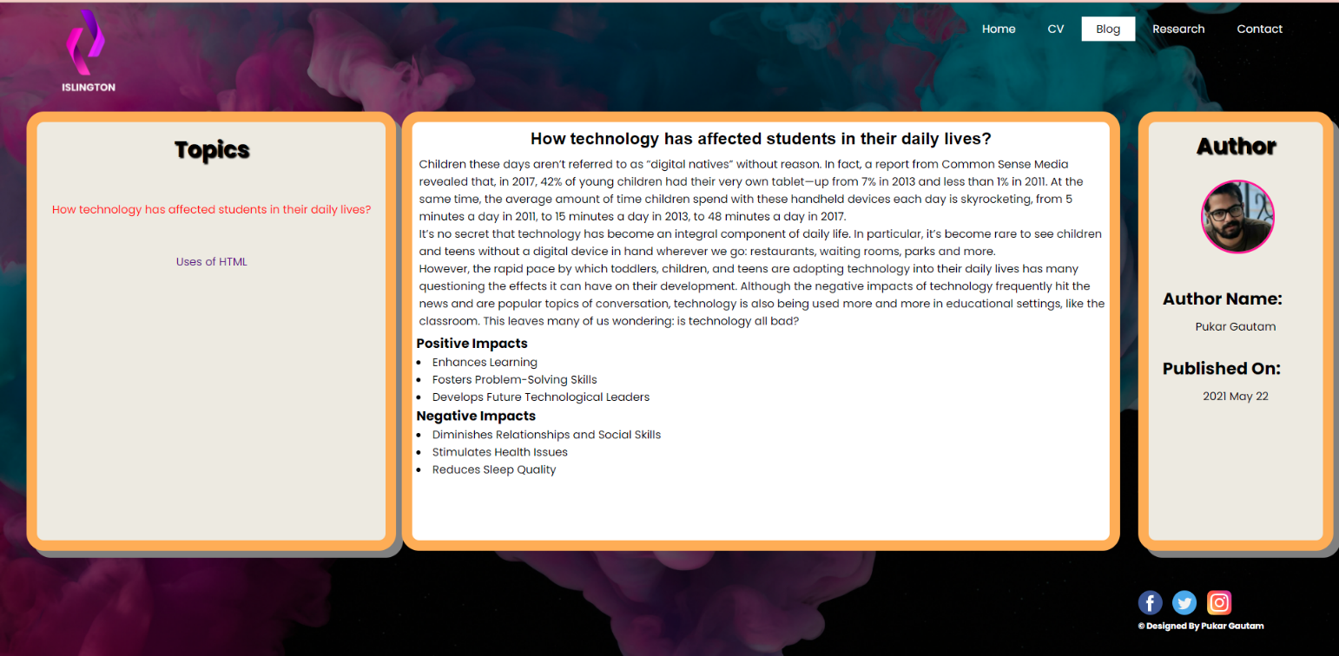

## Research Page

Fourth page was my research page, this page has the references of all content that was used in my website such as navigation bar, footer container and many more.

### Screenshot of wireframe of research page

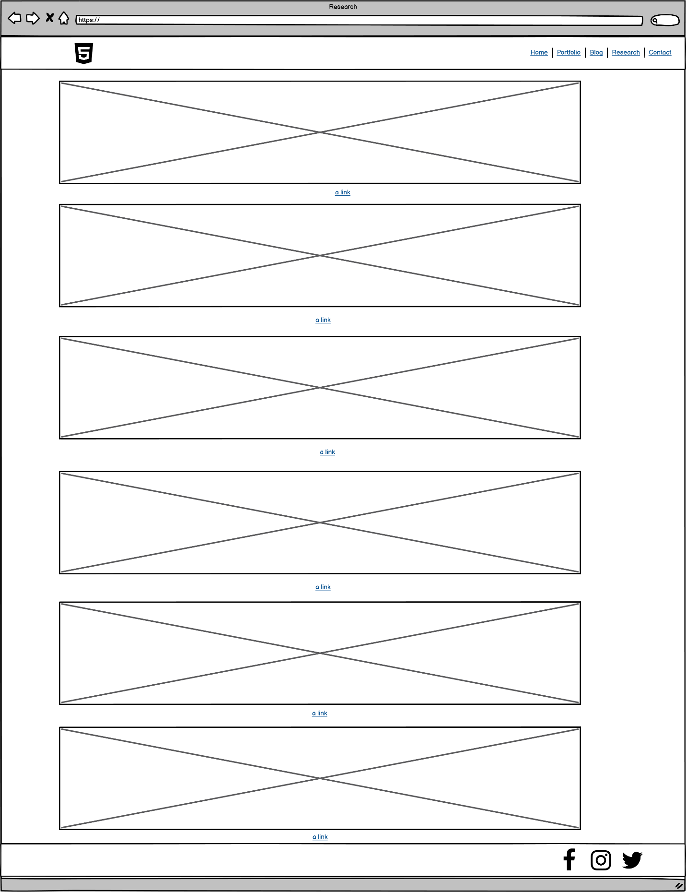

### Screenshot of research page in browser

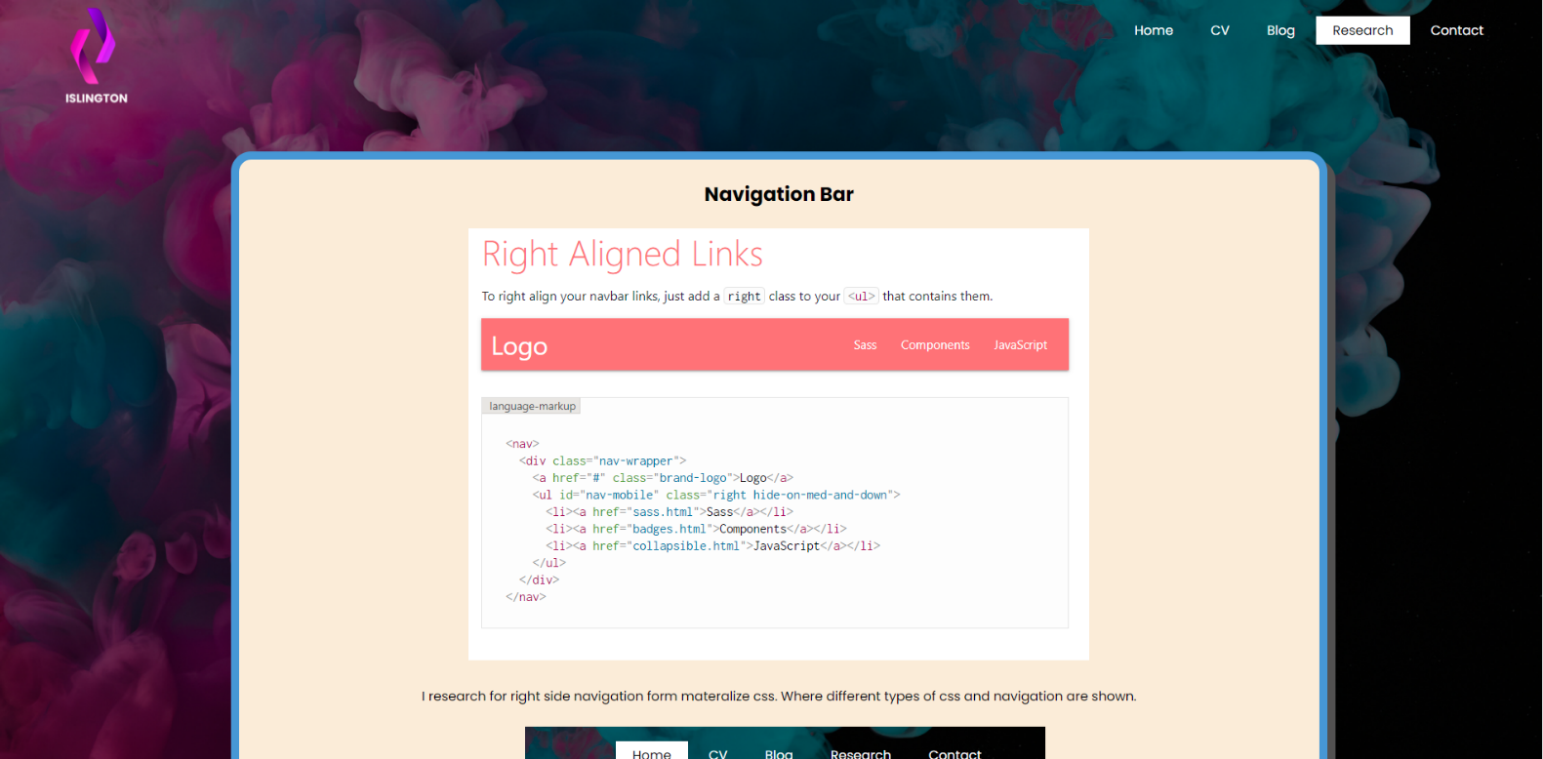

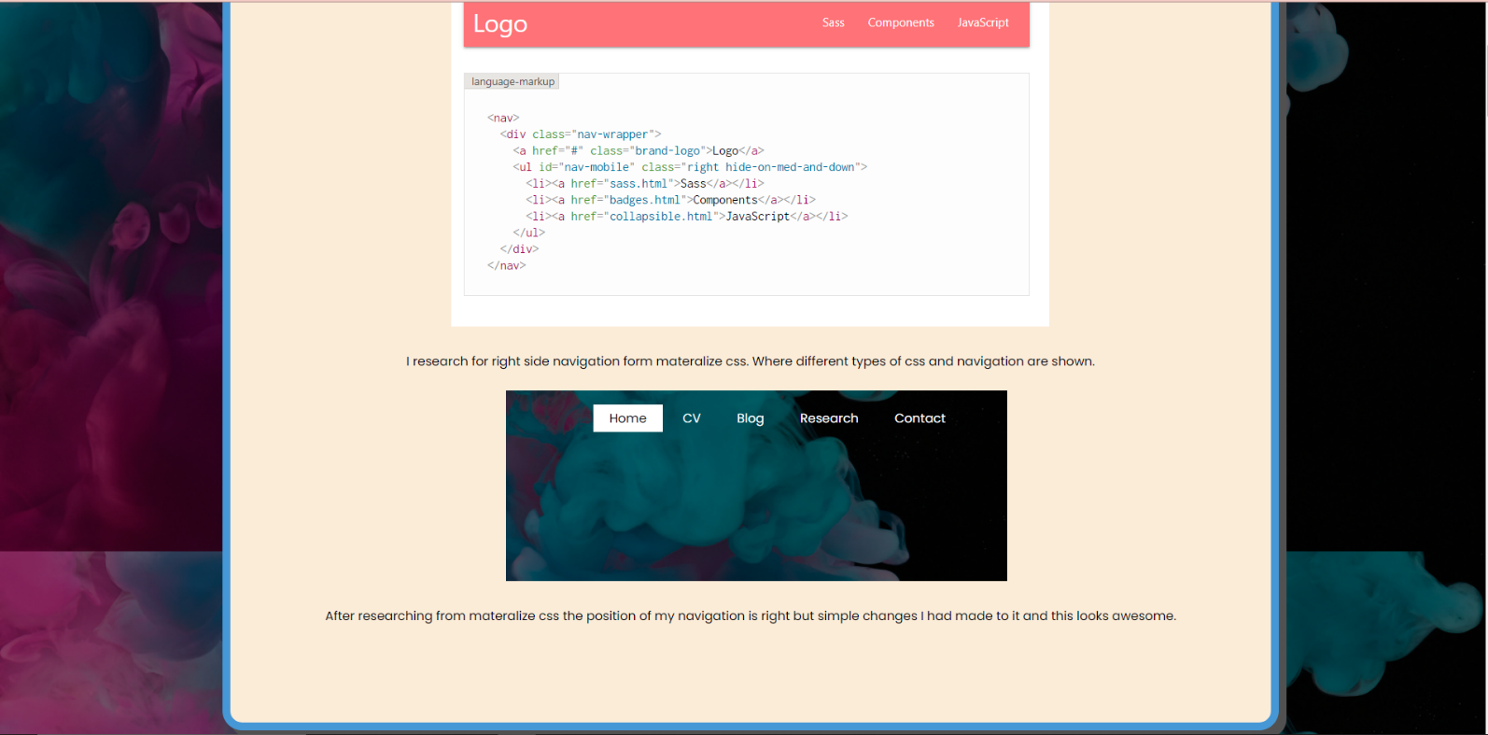

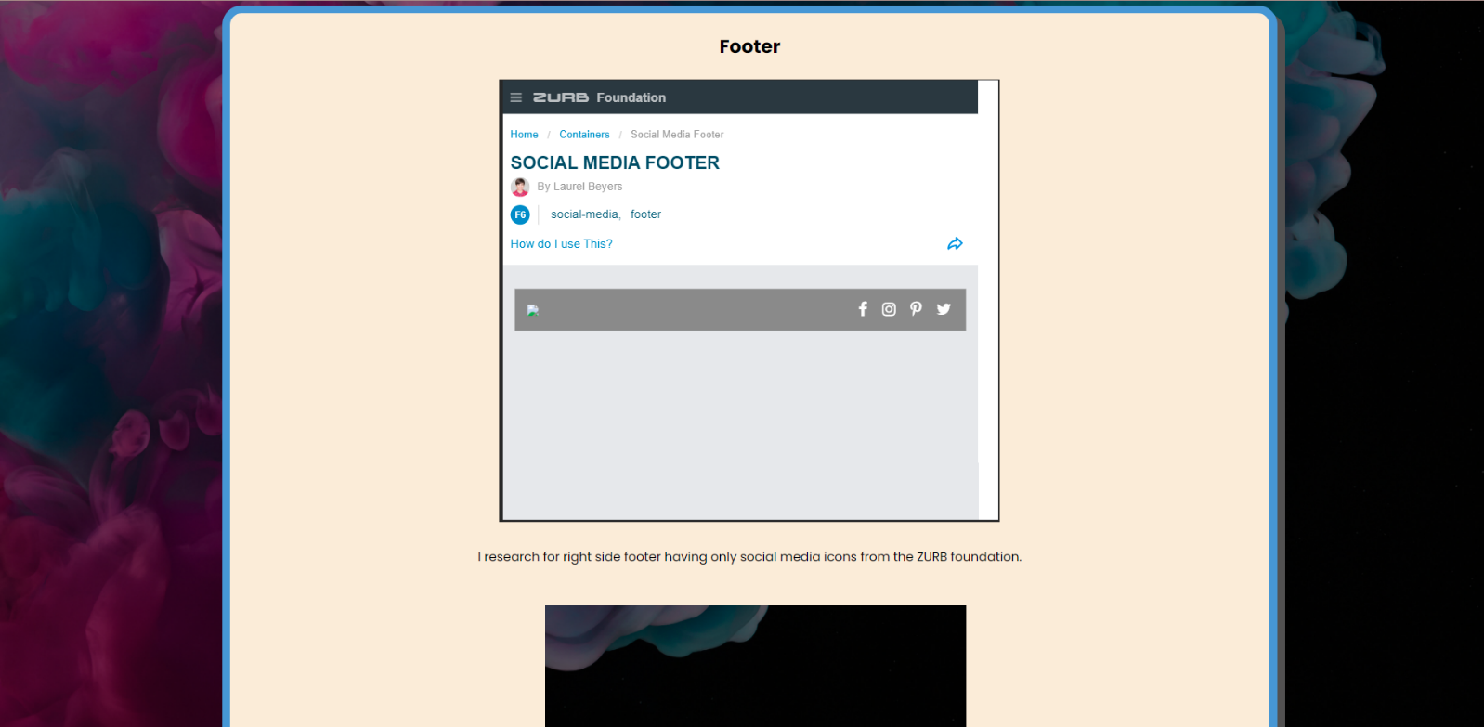

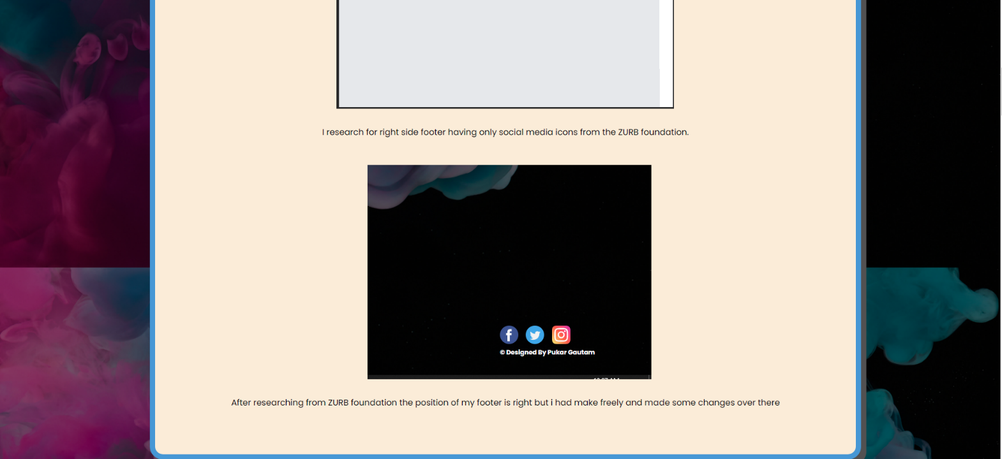

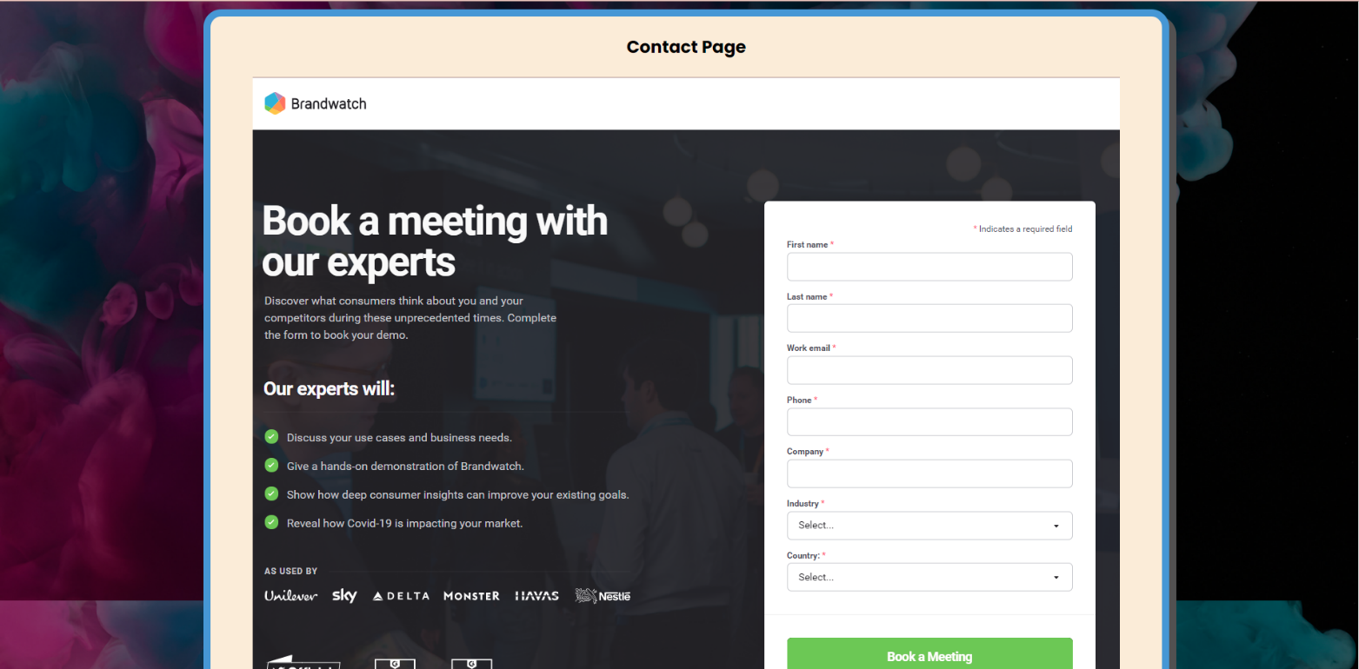

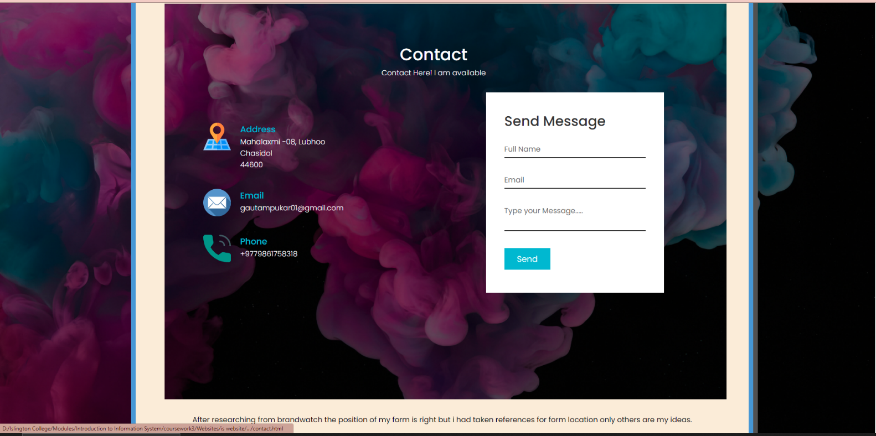

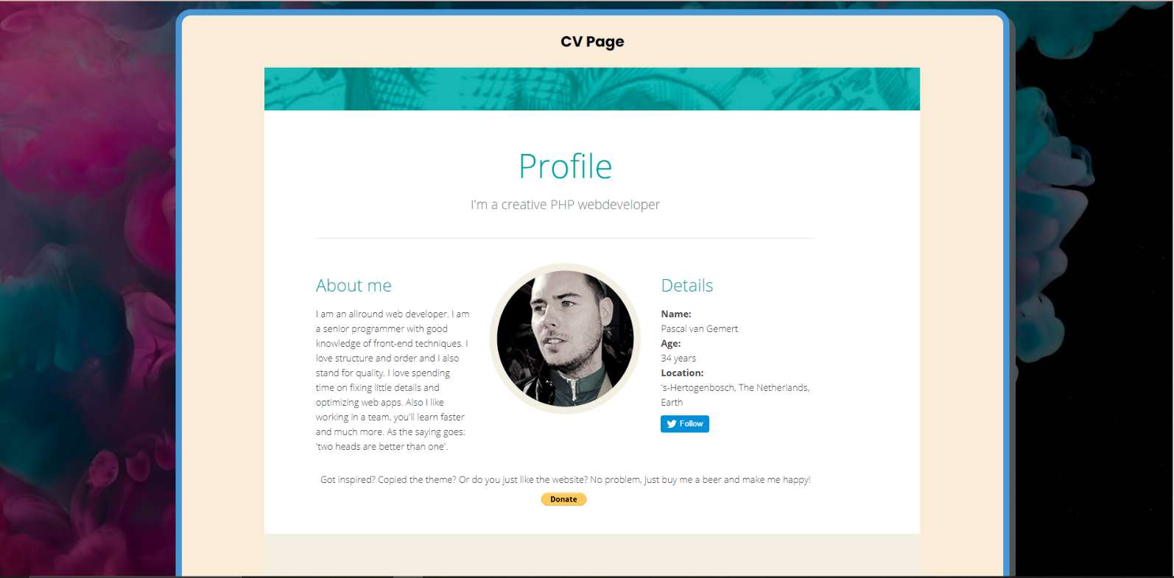

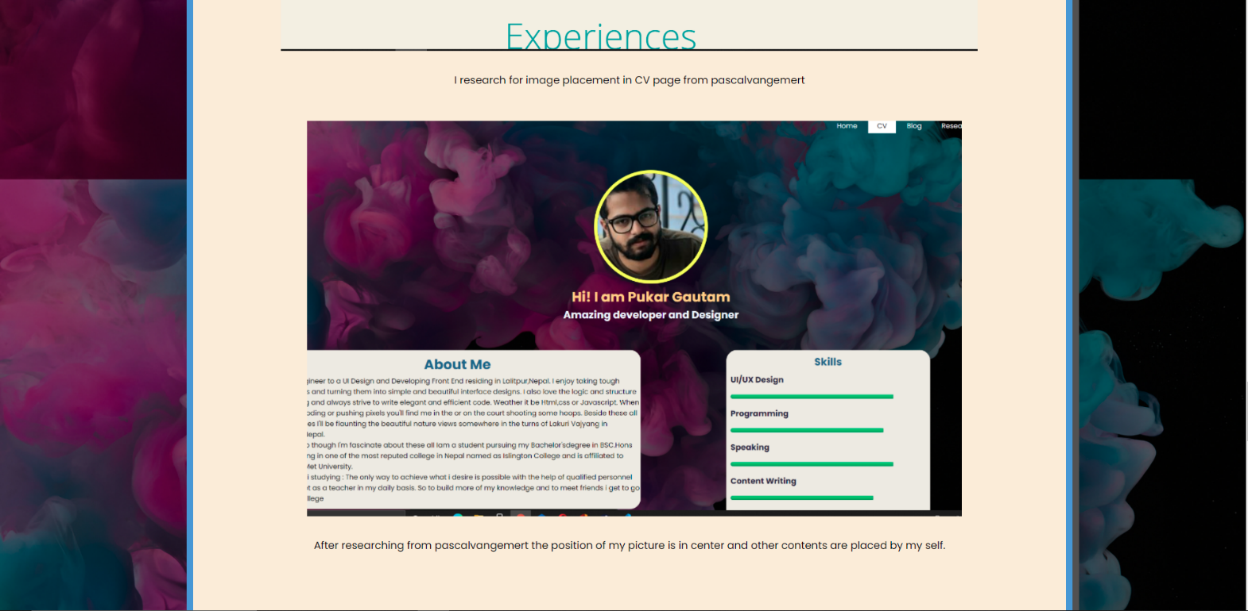

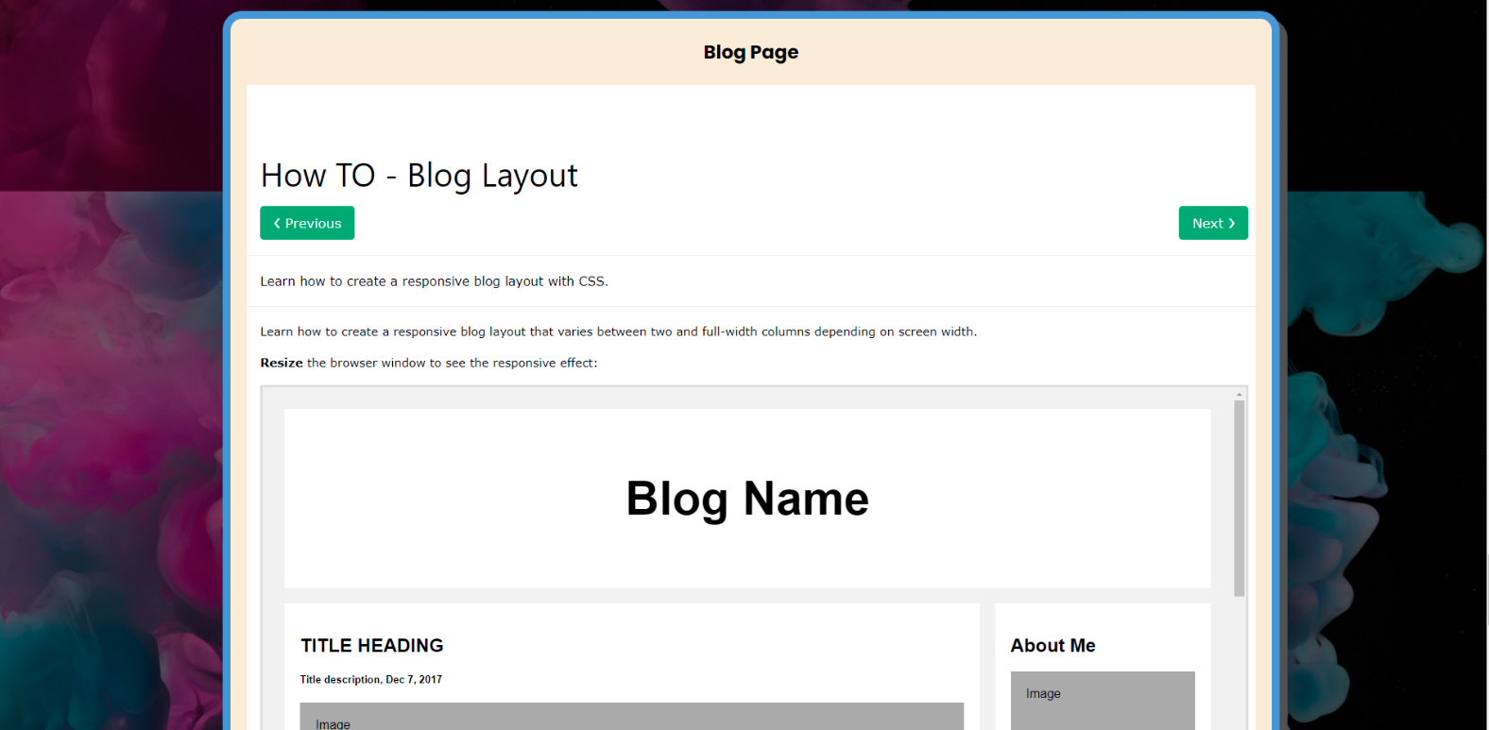

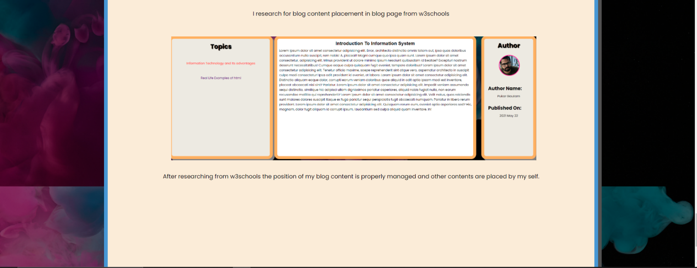

## Contact Page

Fifth page was my contact page where anyone can contact me through their name email and their message including form validation using java script.

### Screenshot of wireframe of contact page

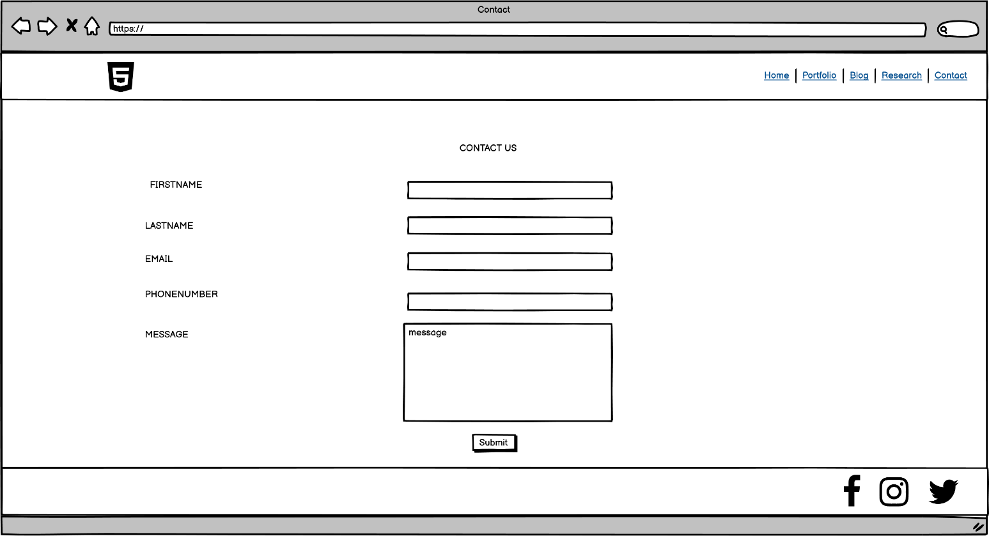

### Screenshot of contact page in browser

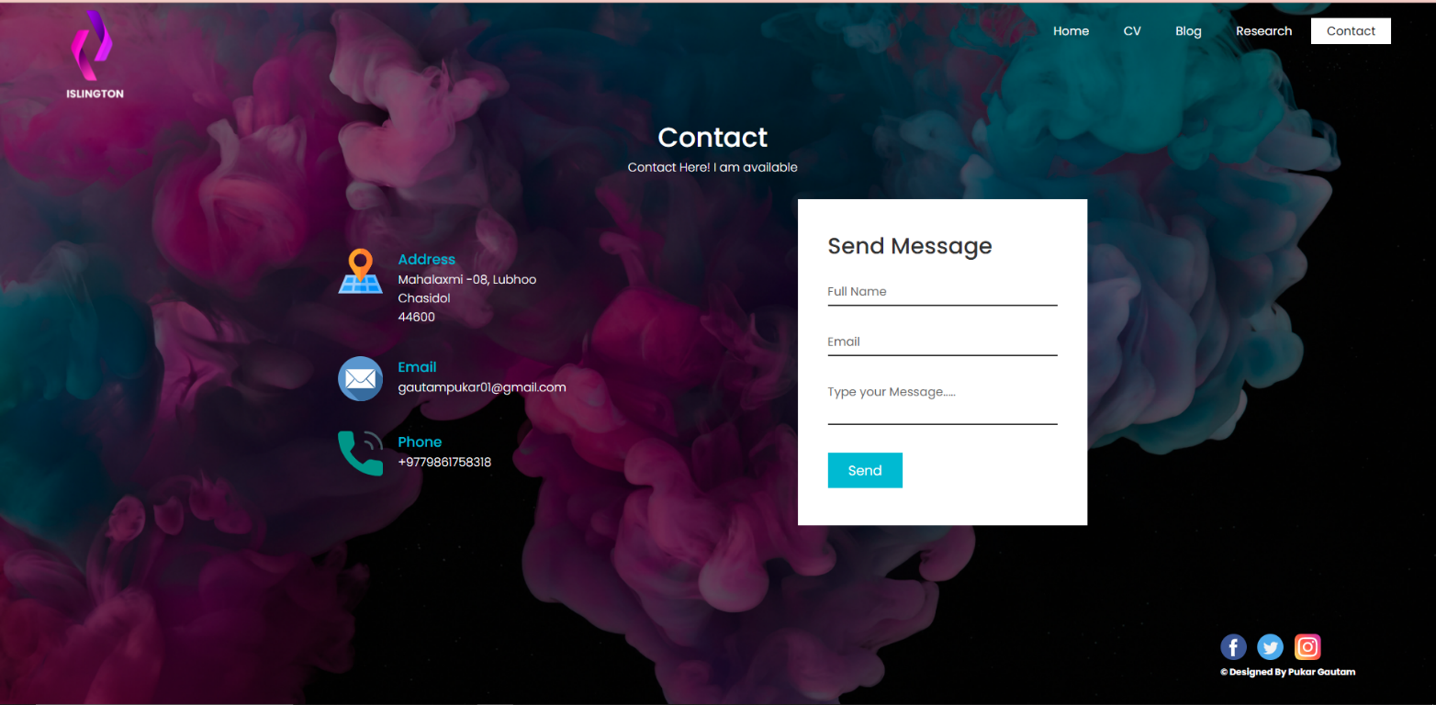

# 3 TESTING

Testing is the process of testing sites or web application for potential bugs or before making live in the side of web development.

## Nav Hover Effect

### TEST 1

|  |  |
| --- | --- |
| TEST | 1 |
| Objective | To make navigation hover when we go through it. |
| Action | * Before hover effect the screenshot is taken * Pointer is taken to the navigation bar to make navigation hover. * After hover screenshot is taken. |
| Expected Result | Navigation gets hover |
| Actual Result | Navigation hovers |
| Test | Test is successful. |

### Output

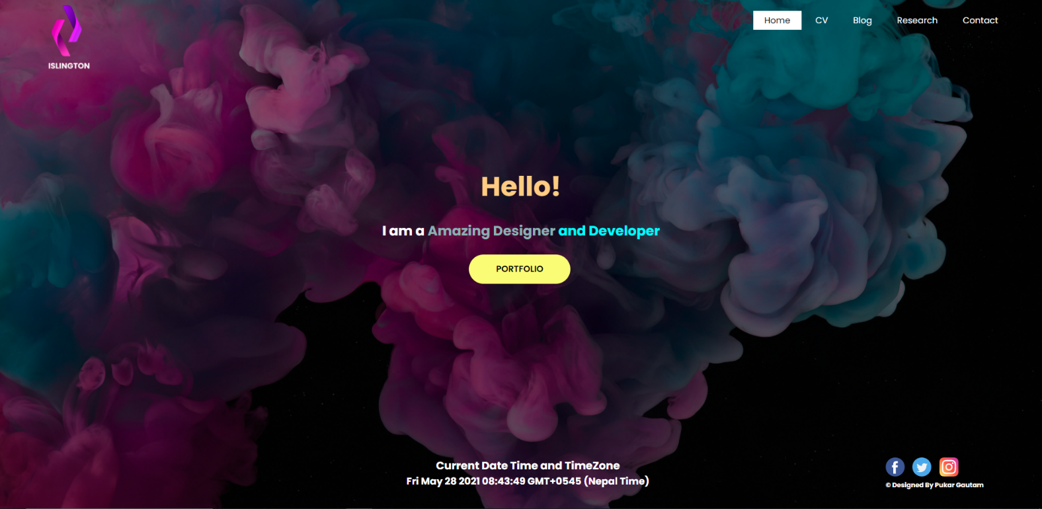

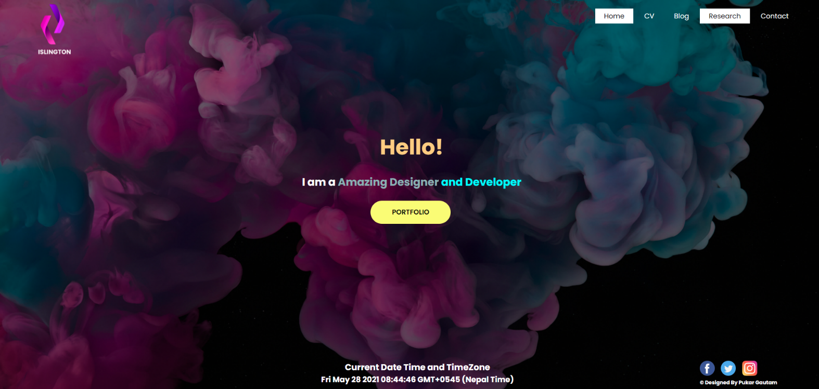

## Internal Link

|  |  |
| --- | --- |
| TEST | 2 |
| Objective | To move through internal link. |
| Action | * Before link is pressed screenshot is taken * Pointer is taken to the navigation bar to move through next page. * After moving to the internal page screenshot is taken. |
| Expected Result | We redirect to internal next page. |
| Actual Result | Properly redirect to internal page. |
| Test | Test is successful. |

### OUTPUT

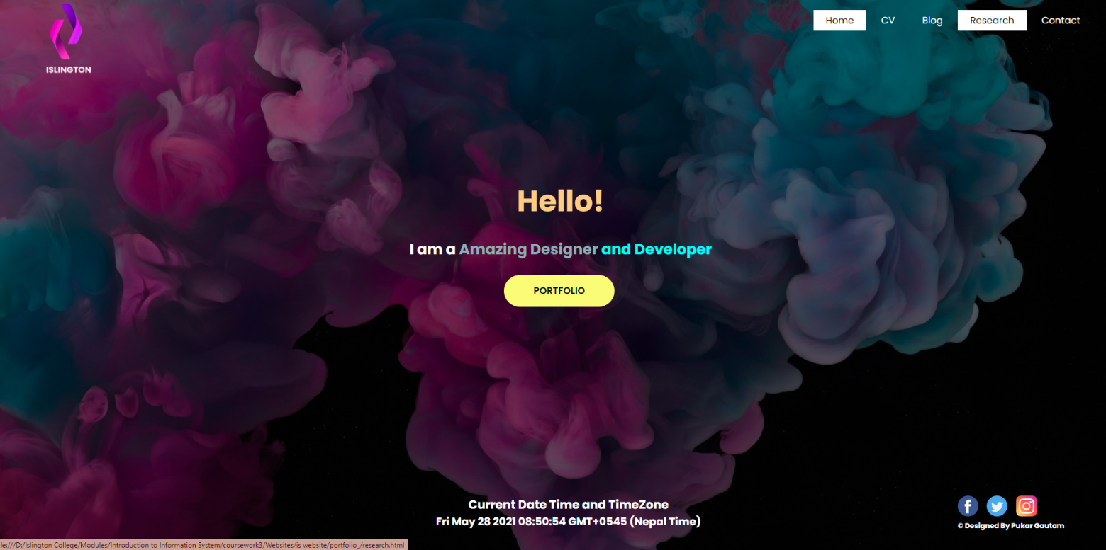

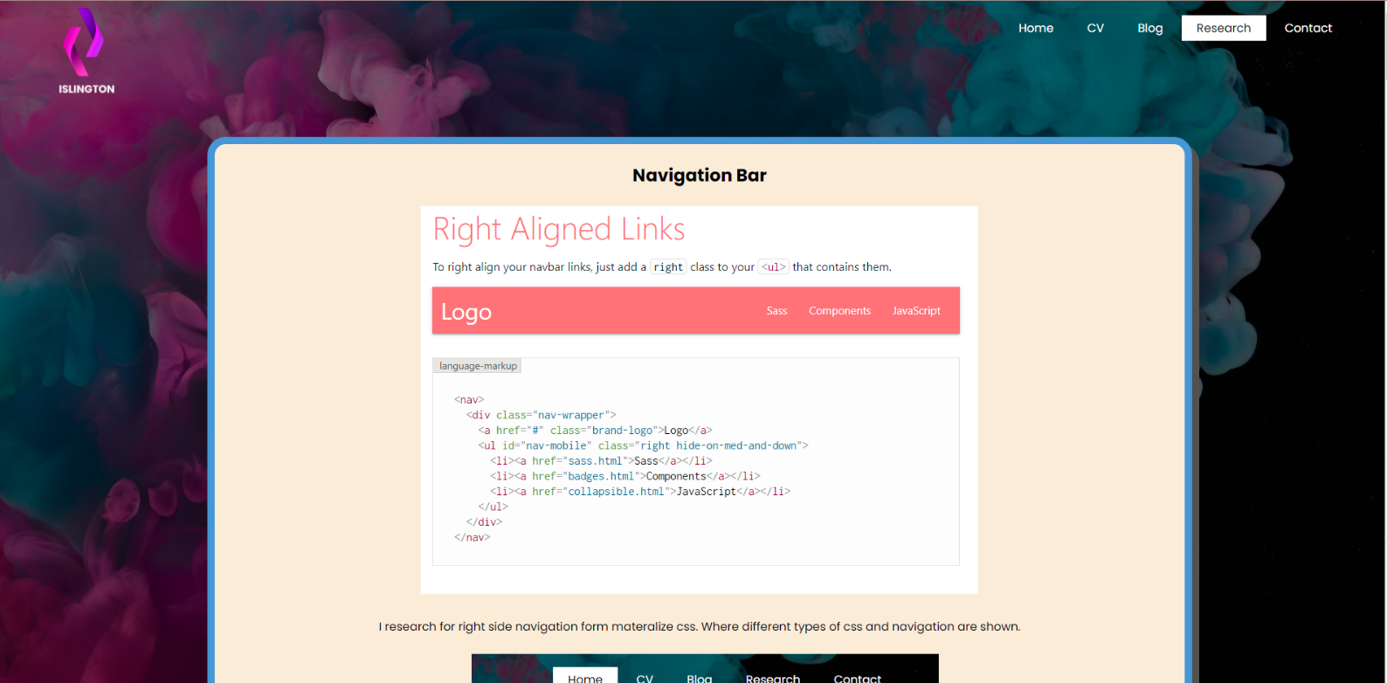

## External Link

|  |  |
| --- | --- |
| TEST | 3 |
| Objective | To move through external link. |
| Action | * Before link is pressed screenshot is taken * Pointer is taken to the follow me icons on cv page to move through next external page. * After moving to the external page screenshot is taken. |
| Expected Result | We redirect to external links in new tab. |
| Actual Result | Properly redirect to external link. |
| Test | Test is successful. |

### OUTPUT

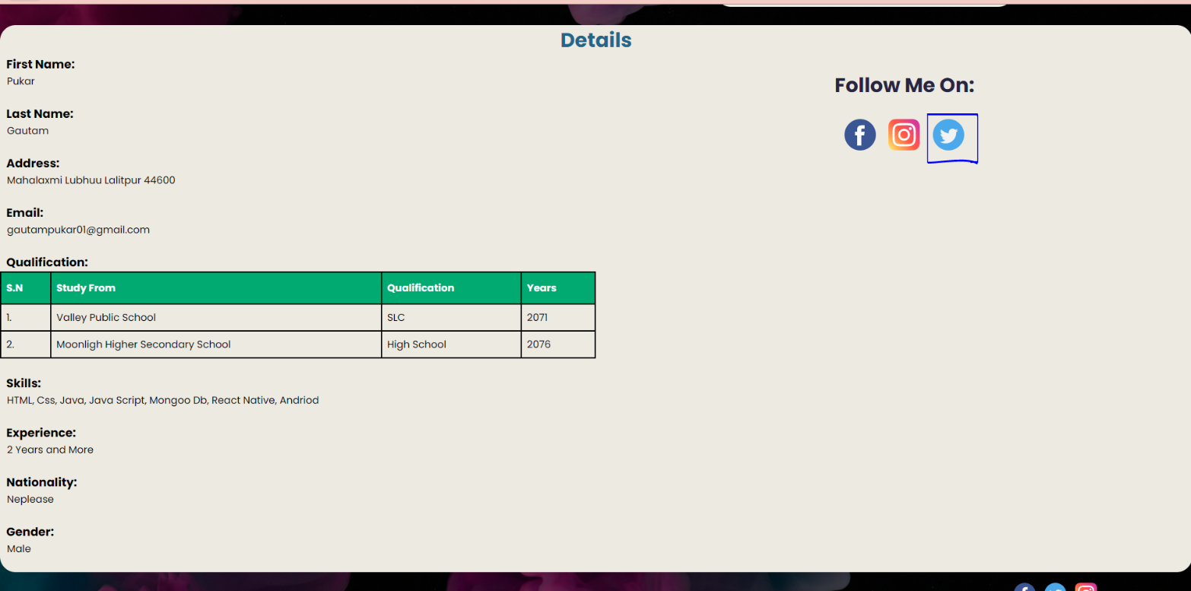

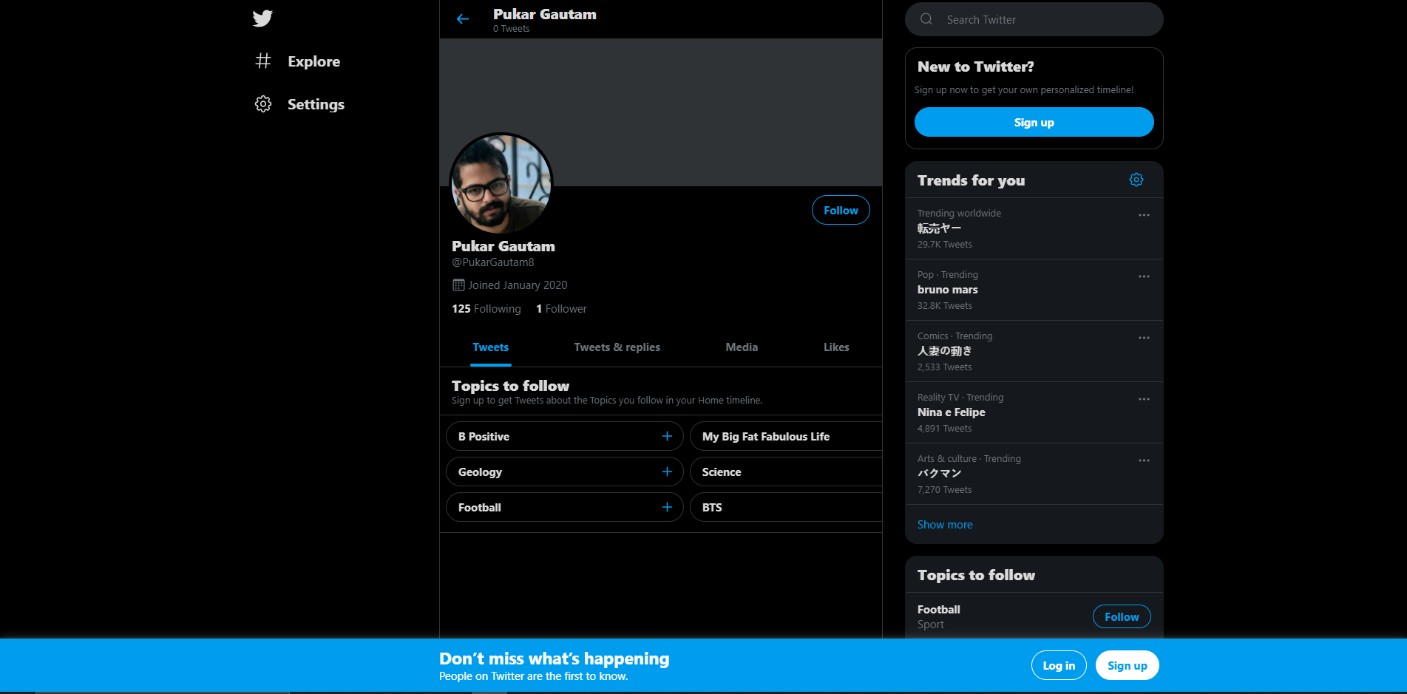

## Form Validation (JS)

|  |  |
| --- | --- |
| TEST | 4 |
| Objective | To check form validation |
| Action | * Before submit button is pressed screenshot is taken * After form is filled up submit button is pressed. * After Showing alert through form validation screenshot is taken. |
| Expected Result | Form validation showing alert |
| Actual Result | Form validation shows proper alert. |
| Test | Test is successful. |

### OUTPUT

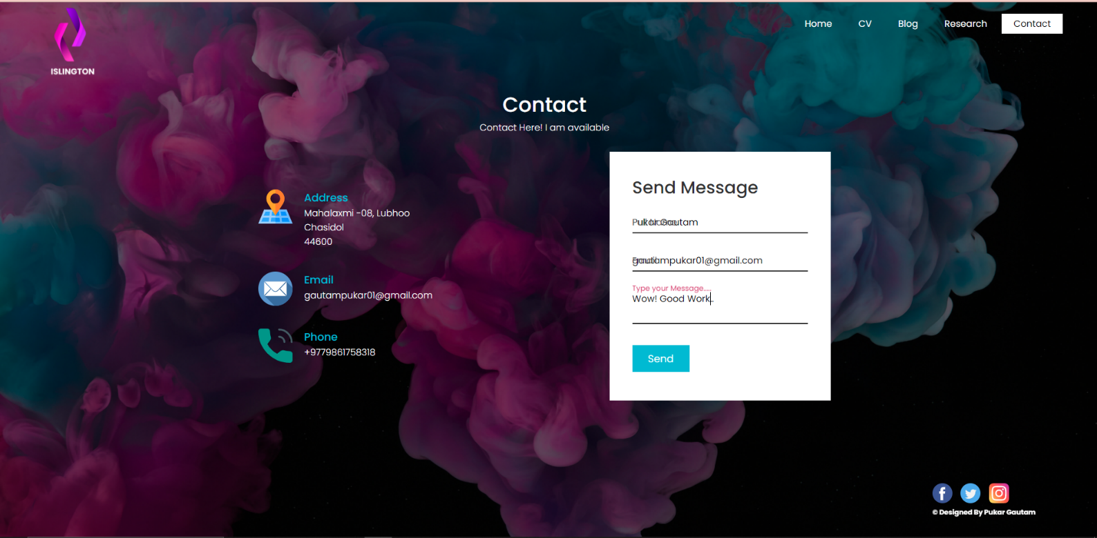

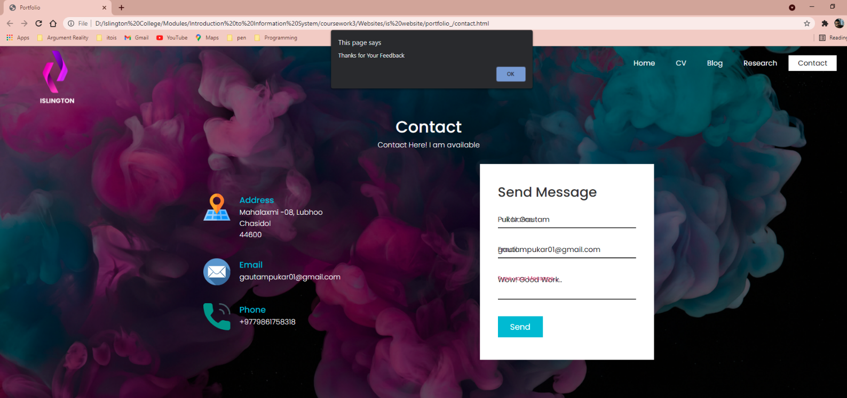

## Dynamic Date and Time (JS)

|  |  |
| --- | --- |
| TEST | 5 |
| Objective | To check dynamically change of date and time. |
| Action | * Page having date and time, screenshot is taken. * After waiting of certain minutes screenshot is taken again. |
| Expected Result | Time changes dynamically |
| Actual Result | Time changes dynamically. |
| Test | Test is successful. |

### OUTPUT

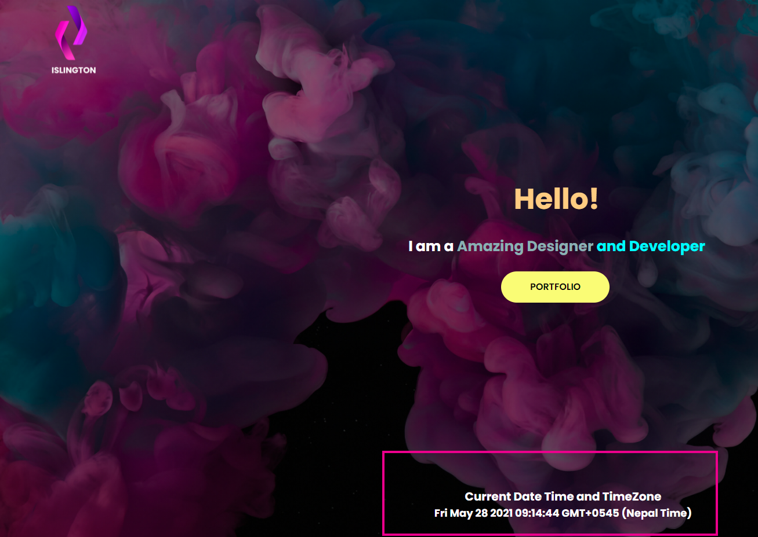

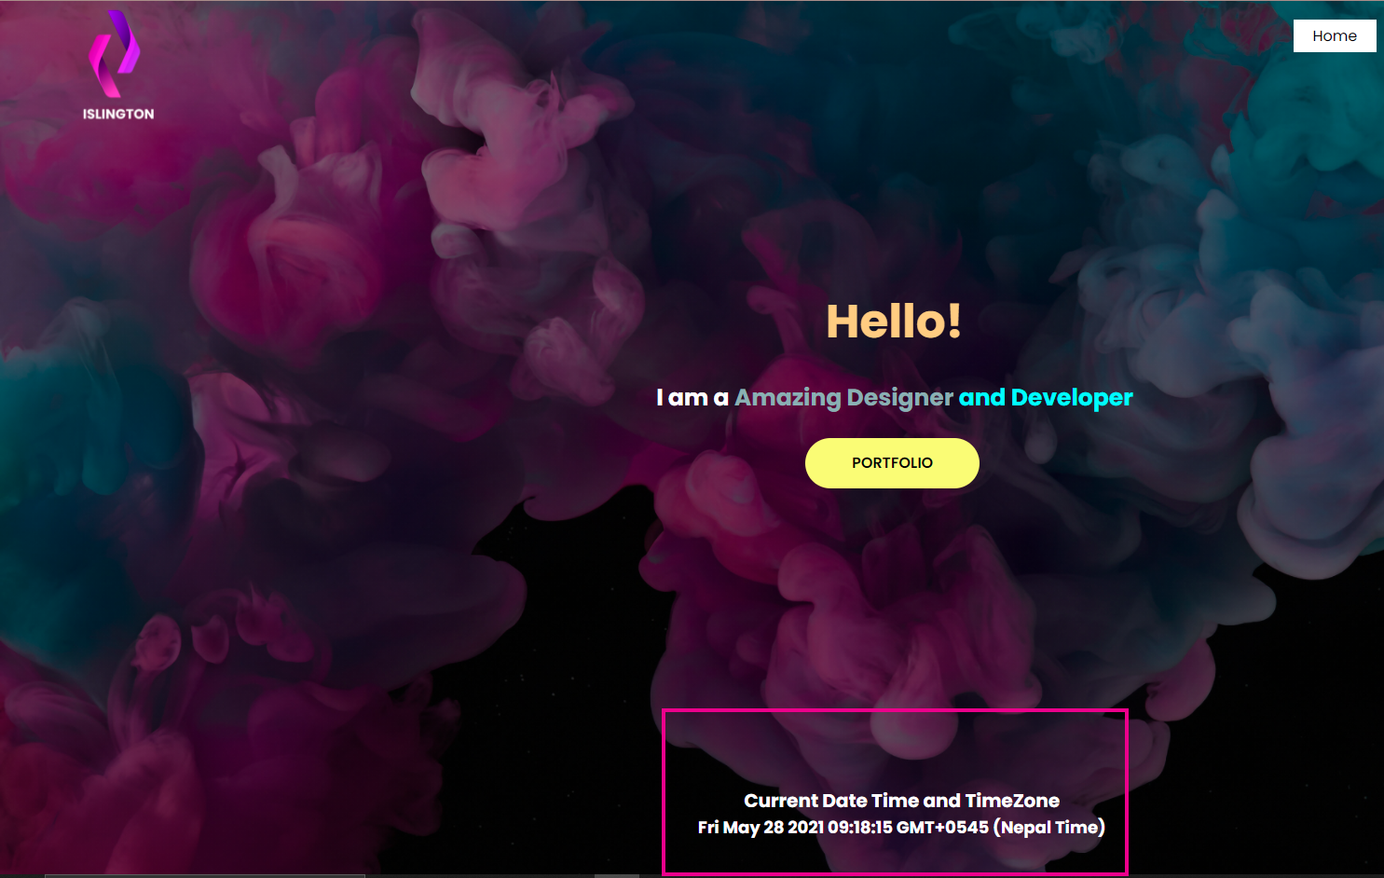

## IMAGE Slider (JS)

# Conclusion

Finally, in this coursework, a website is created using many languages and designs. During the development of the site, some errors were encountered, which were resolved by consulting the internet, the module teacher, and the lecture slides. Balsamiq was used to create wireframes for the website before it was built. I used certain internet sites as references for developing the coursework website. The most useful website was w3schools, from which I received a lot of assistance with this coursework. To make the site designable, similar types of designs were used. Different links were employed to shift the page from one page to the next, and one of the pages also included social media links.

Overall, making this website is very interesting. Lots of research is done to make this website. As section used in website such as navigation, footer, blog page, contact page all are made through researching from different sites and including own design. Making this website is very useful in learning all HTML, CSS and JavaScript. This makes us understand that where tags are needed or used, where we navigate to page, how internal, inline and external CSS are used, how to use JavaScript and make website a little dynamic and stunning.

# References

**There are no sources in the current document.**